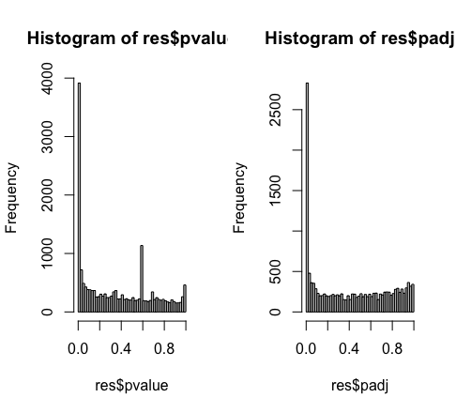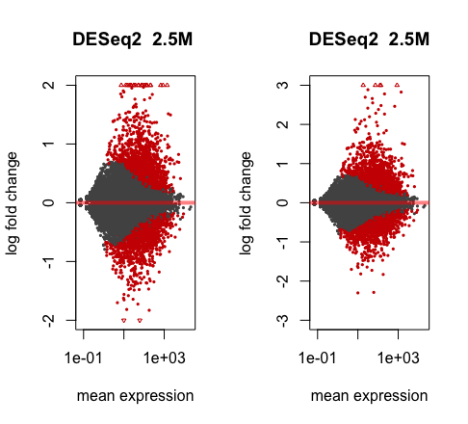

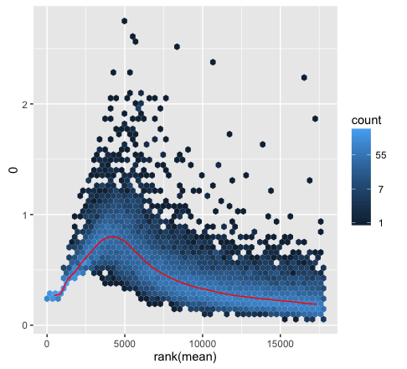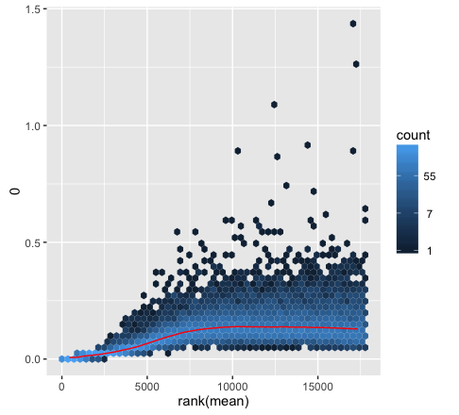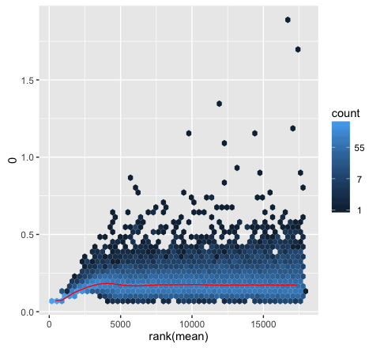

In the meanSD plot, the red line depicts the running median estimator, so we can see from the first graph, there is a dependence between the standard deviation and the mean. However, the last two graph are better at removing dependence of std versus means, since flatness shows no variance-mean dependence.

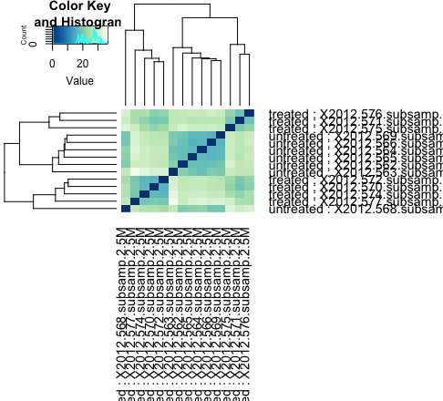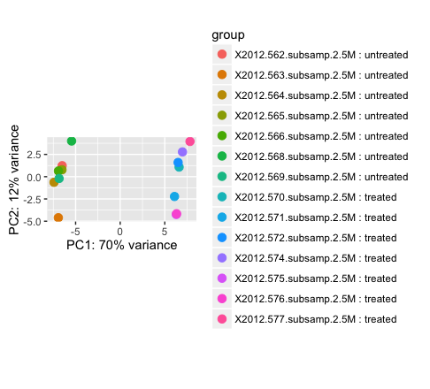

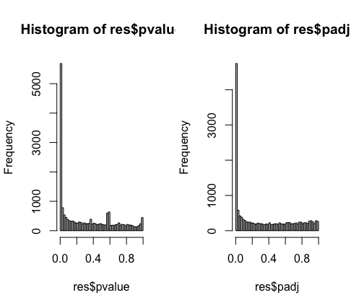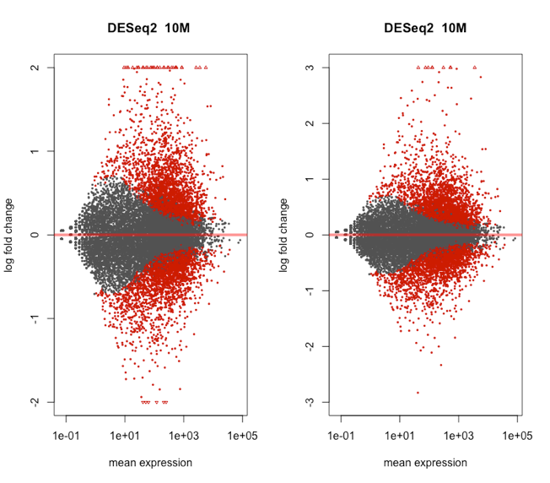

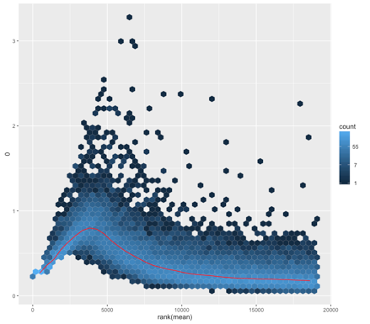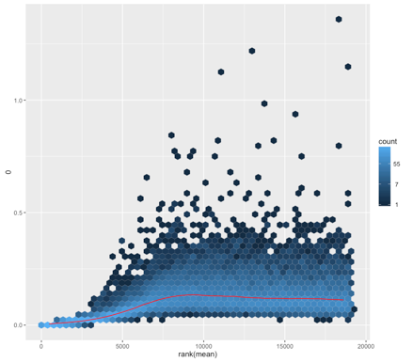 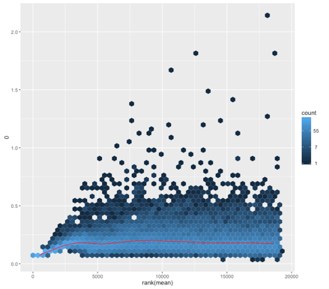

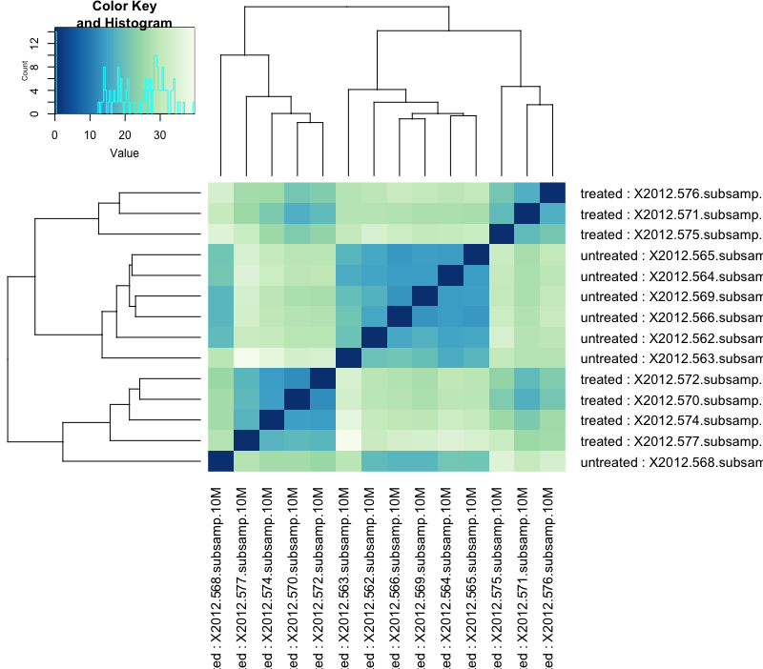 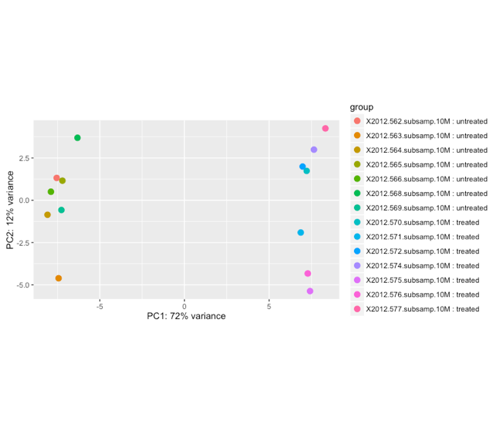

The heat map and hierarchical clustering for all three depth seems identical. First we chose 30 most highly expressed genes. Then we calculate sample to sample distances so we can make the heat map to look at the clustering of samples. As this was a control experiment to show that slightly different experimental setup for the different samples, and wasn’t responsible for the observed expression differences, however there still showed some treatment effect. And the PCA shows little data but a very obvious clustering group showed the treatment effect as well.

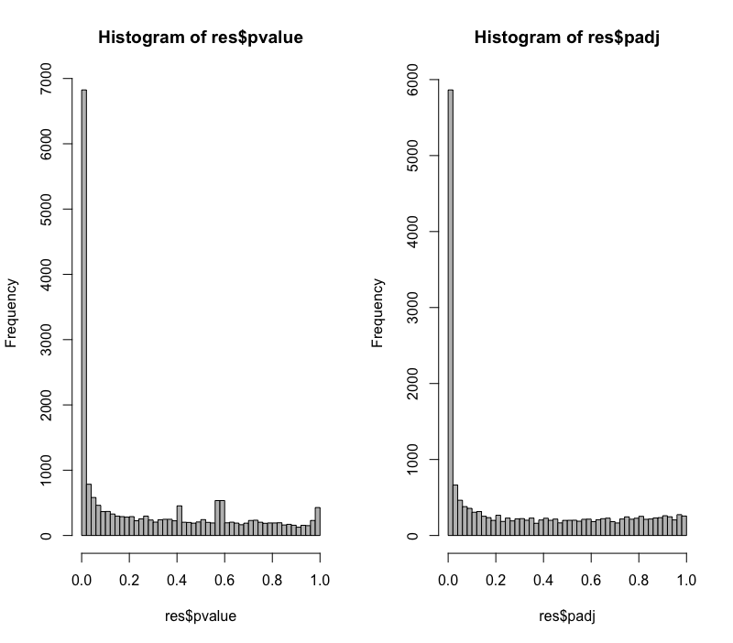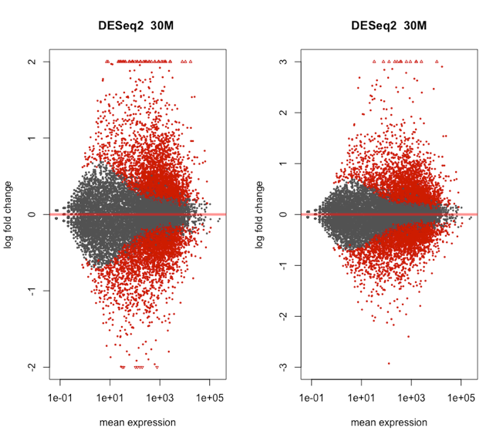

The MA plot showed visual representation of two channel DNA microarray gene expression data which has been transformed onto the M (log ratios) and A (mean average) scale. The microarray with 30M depth shows more spreads out comparing to 2.5M and 10M. The central line lays on 0, which showed the microarray data has been normalized.

